**DAILY ONLINE ACTIVITIES SUMMARY**

|  |  |  |  |  |  |  |  |  |
| --- | --- | --- | --- | --- | --- | --- | --- | --- |
| **Date:** | **25 June** | | | | | **Name:** | **Shanbhag Atish Manoj** | |
| **Sem & Sec** | **6th Sem ‘B’ Sec** | | | | | **USN:** | **4AL17CS085** | |
| **Online Test Summary** | | | | | | | | |
| **Subject** | | **JSP and Data Structures** | | | | | | |
| **Max. Marks** | | **--** | | **Score** | | | **JSP-9/10**  **DS-8/8** | |
| **Certification Course Summary** | | | | | | | | |
| **Course** | **Placement Training** | | | | | | | |
| **Certificate Provider** | | | **Mr. Sayyesh**  **Mr. Venkatesh** | | **Duration** | | | **4 Hours** |
| **Coding Challenges** | | | | | | | | |
| **Problem Statement: 1 program** | | | | | | | | |
| **Status: Executed** | | | | | | | | |
| **Uploaded the report in GitHub** | | | | | **yes** | | | |
| **If yes Repository name** | | | | | <https://github.com/atish-shanbhag/Updates> | | | |
| **Uploaded the report in slack** | | | | | **yes** | | | |

**Jsp programming Session 1:**

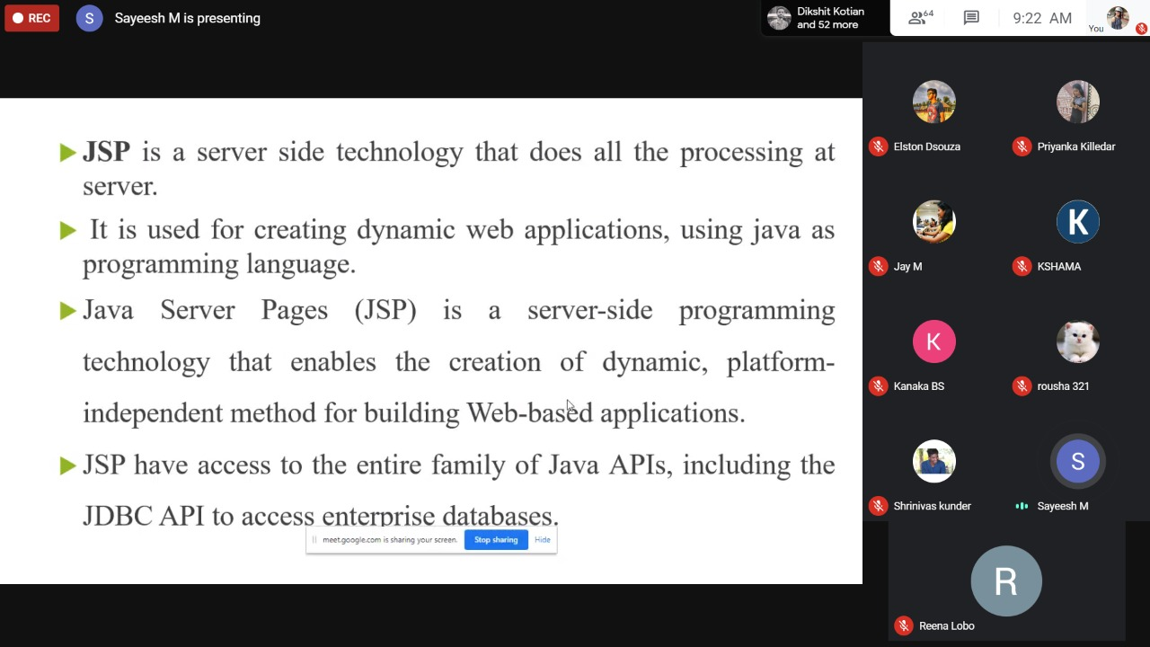

**Data Structures Session 2**

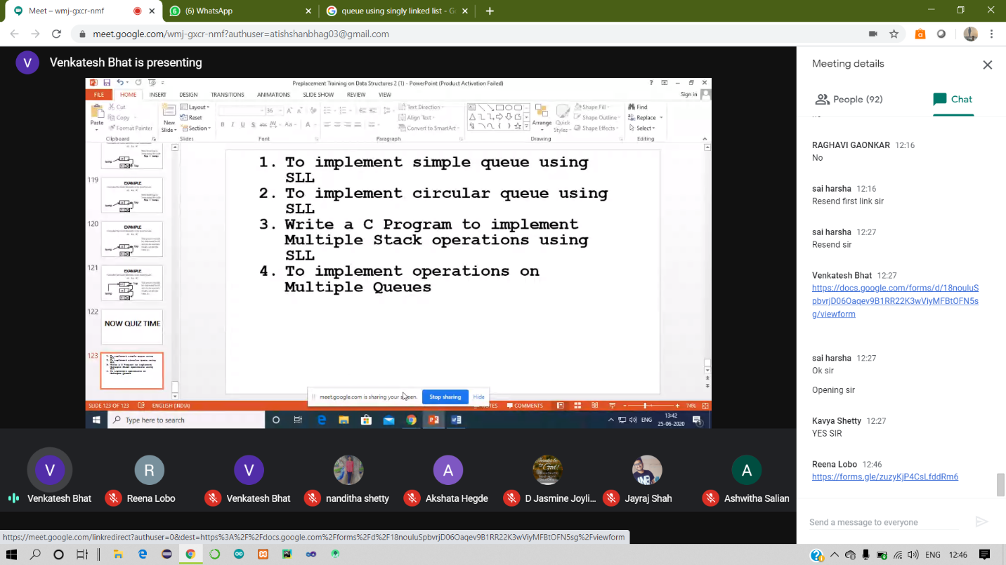

**Coding Challenges Details:**

25-June – Code:

**Program 1 -**

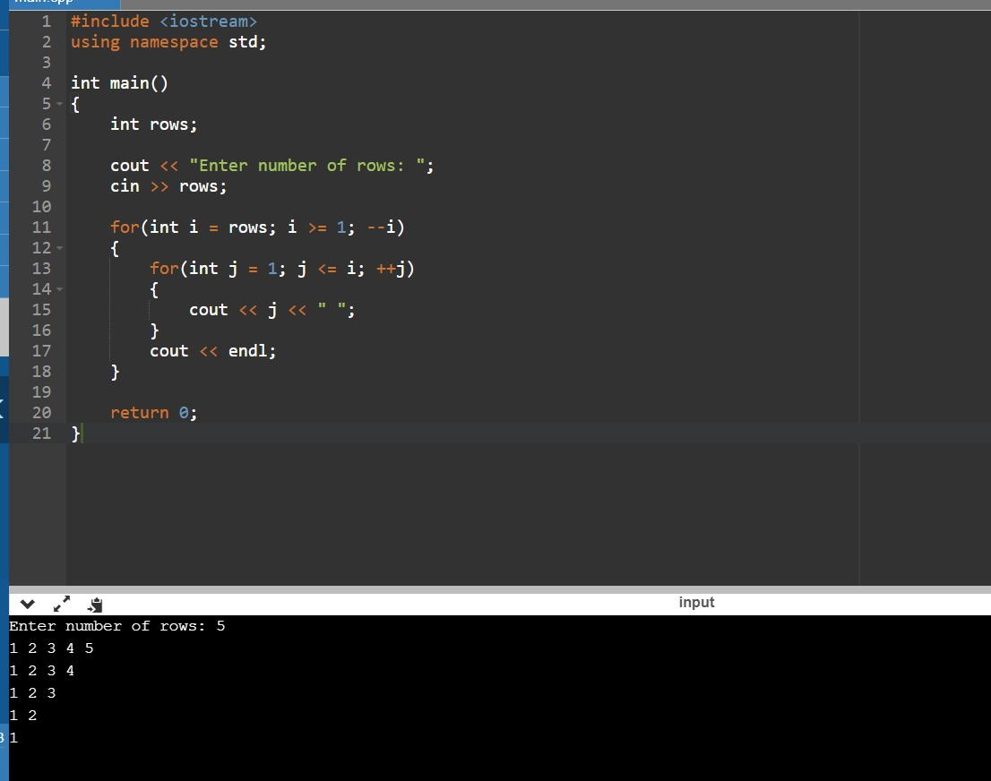

**1-For Report and daily coding challenges** 🡪

[**https://github.com/atish-shanbhag/Updates**](https://github.com/atish-shanbhag/Updates)

**2-For Exercises and Worked problems of workshop** 🡪

[**https://github.com/atish-shanbhag/Python_Programming_in_DA_and_ML**](https://github.com/atish-shanbhag/Python_Programming_in_DA_and_ML)